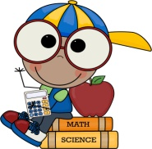
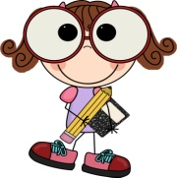
Ms. Misselhorn’s Messages
October 13, 2015

Calendar  Monday -Please review all papers sent home. Send back signed forms in your child’s Daily Folder. Homework: Spelling calendar & baggie book (due Friday).  Tuesday - Return daily folder, any signed forms. Homework: Spelling calendar & baggie book (due Friday).  Wednesday - Return daily folder, any signed forms. Homework: Spelling calendar, complete math page & baggie book (due Friday).  Thursday - Return daily folder, any signed forms. Homework: Spelling calendar, complete math page & baggie book (due Friday).  Friday- Return folder, homework journal, math homework and baggie book. Spelling test day!!  Information  Students should pick one activity on the spelling calendar to practice current spelling words each night. This week students will have Baggie Books on Big Universe. The students should read the book 2 times each night and orally answer questions from the list provided in the blue folder. Students will have 2-3 math worksheets to complete each week. All homework is checked on Friday.  Please send in a healthy snack with your student everyday. We have snack at 10:00 am.  No candy please!  Our class has earned 135 drops!! We have decided to have a movie time and a popcorn snack!! | Reminders  October 12- Boosterthon Kick-off  October 13- mClass night @5:30  October 16- Early Release (Dismissal 1:15pm)  October 21- FUN RUN & Track out!  October 24- Harris Creek Beautification Day  November 12- Track in  *Please remember to read through all the paperwork in your child’s daily folder. Your child’s class work will come home weekly in the Monday envelope, for you to take out and enjoy.  Our Focus  Reading: Describe characters, settings and major events in a story, using key details. In spelling, we are still working on final consonant blends.  Writing: Students will start working on opinion writing this unit. We will discuss the difference between fact and opinions and work on supplying reasons for our opinions.  Math: Focus on place value- students will be able to relate teen numbers to a ten and extra ones; represent teen numbers in different ways and learn a quick method for drawing tens and extra ones.  Science: Balance and Motion- understand how forces (pushes and pulls) affect the motion of an object.  Thanks!  Ms. Misselhorn  amisselhorn@wcpss.net

